INTERACTIVE AND VISUALLY APPEALING DASHBOARD

The Digital Well-Being & Addiction Insights Dashboard is an interactive Power BI dashboard designed to analyse and understand smartphone usage patterns and their impact on digital well-being. It provides meaningful insights into key factors such as screen time, smartphone addiction levels, sleep duration, gaming activity, social media usage, and notification frequency.
The dashboard uses interactive charts, graphs, cards, and filters to present the data in a simple and user-friendly way. Users can explore different usage patterns, compare categories, and identify trends related to excessive smartphone use. By presenting these insights visually, the dashboard helps users better understand their digital habits and encourages greater awareness of healthy smartphone usage.

DASHBOARD FEATURES:

- Clear and Intuitive layout
- Relevant Visualizations
- KPI Cards
- Interactive Filters and Slicers
- Charts and Graphs
- Easy-to-understand Design
- Age Group and Gender Analysis
- Addiction Level Analysis

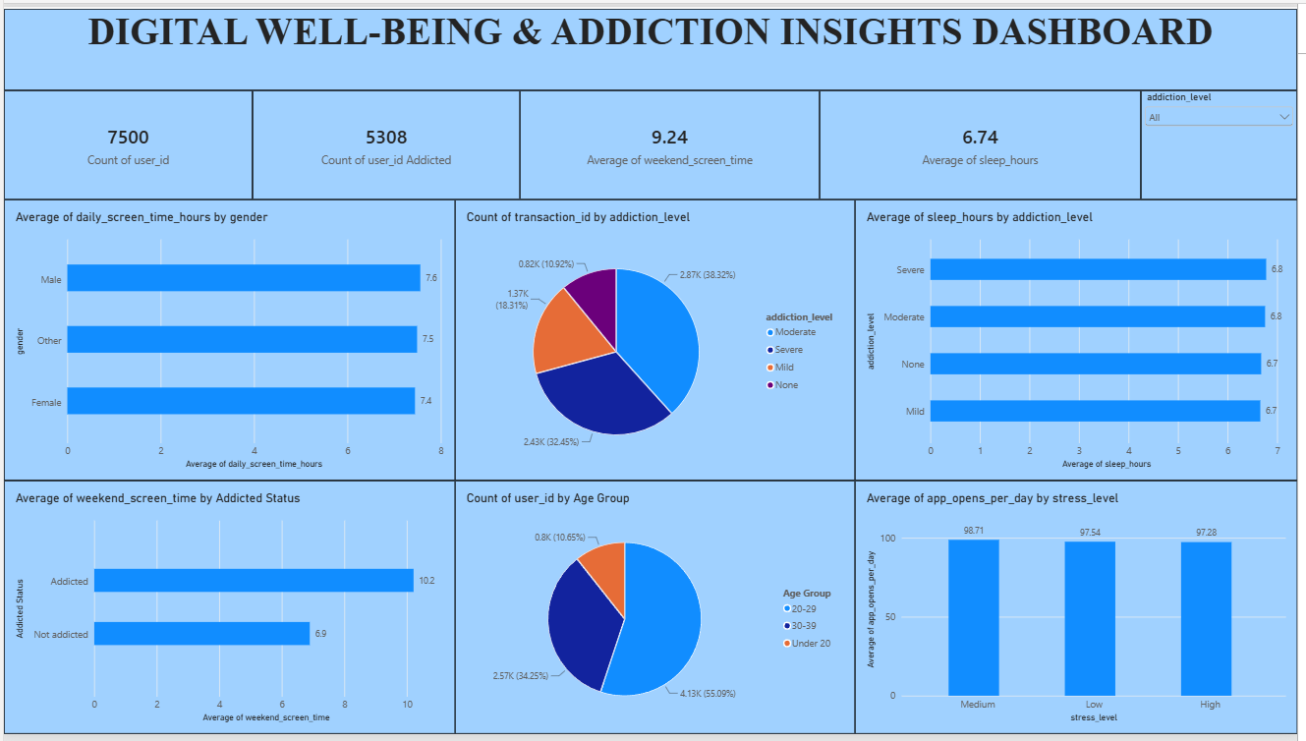

Potential Outcomes from Dashboard Visualization:

- Screen Time Analysis: The dashboard shows the average daily screen time of users.
- Addiction Analysis: The dashboard shows users according to different addiction levels such as None, Mild, Moderate and Severe.
- Gender Analysis: The dashboard compares average screen time among different genders.
- Age Group Analysis: The dashboard compares screen time across different age groups.
- Digital Activity Analysis: The dashboard compares gaming, social media, app usage and notifications.
- Sleep Analysis: The dashboard helps examine screen time and sleep-hour patterns.
- Weekend Usage: The dashboard displays the average weekend screen time.
- Overall Digital Well-Being: KPI cards provide a quick summary of important digital usage measures.

